**ECE 361 Project Part 1**

**Group 7**

**Name 1** Brandon Liston

**Name 2** Andre Morris

**Name 3** Eric Wan

**Summary:**

Part 1 of the project involved taking two data sets, which a target was present and no target was present. One of the goals was to find the optimal threshold of detecting a target greater when greater than the threshold using ROC analysis, which is the plot of probability of false alarm versus the probability of detection. Using this plot, the ideal threshold is extracted as the minimum point from the ROC curve to the point of 1 probability of detection and 0 probability of false alarm. Measurements to further characterize this threshold on the data given were taken, such as ppv to mark how accurate the target is present given it was detected, area under the ROC curve which marks the performance of the detector and is used in calculating performance index, and standard deviation to measure the confidence interval. Finally comparing the optimal results to the intersection results of the two fit densities.

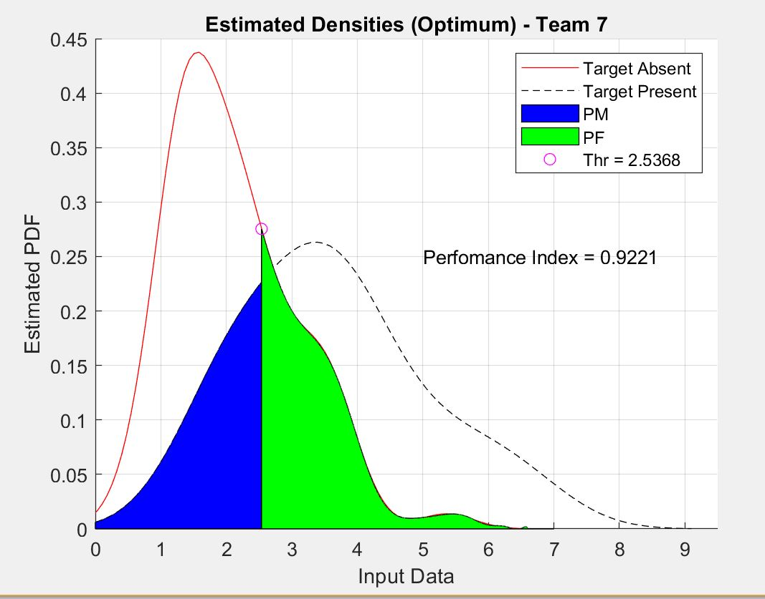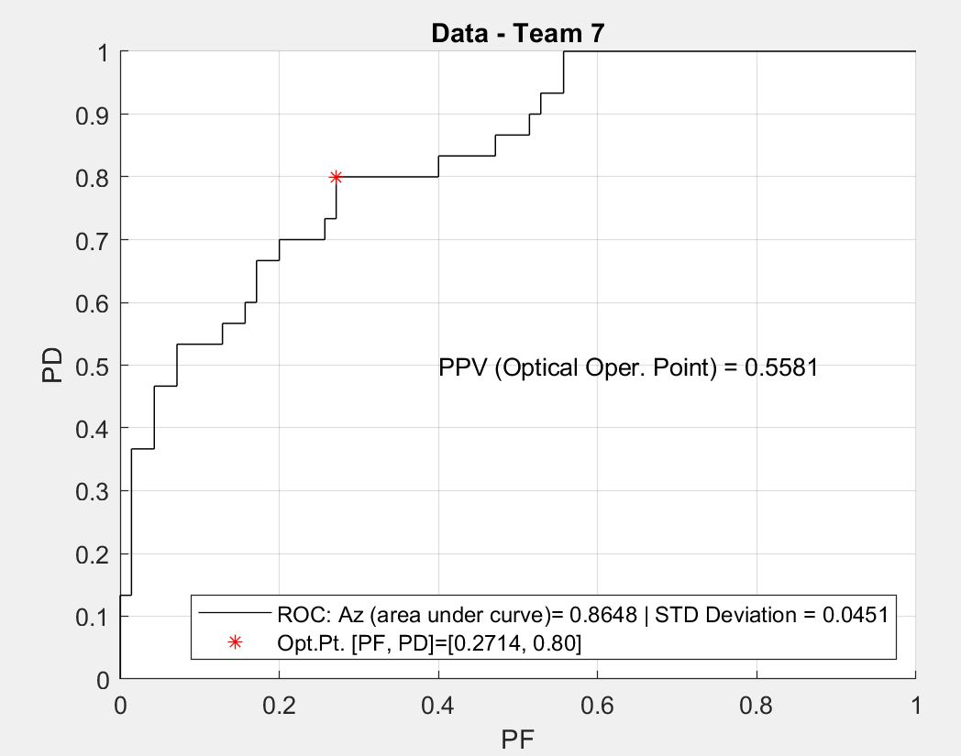

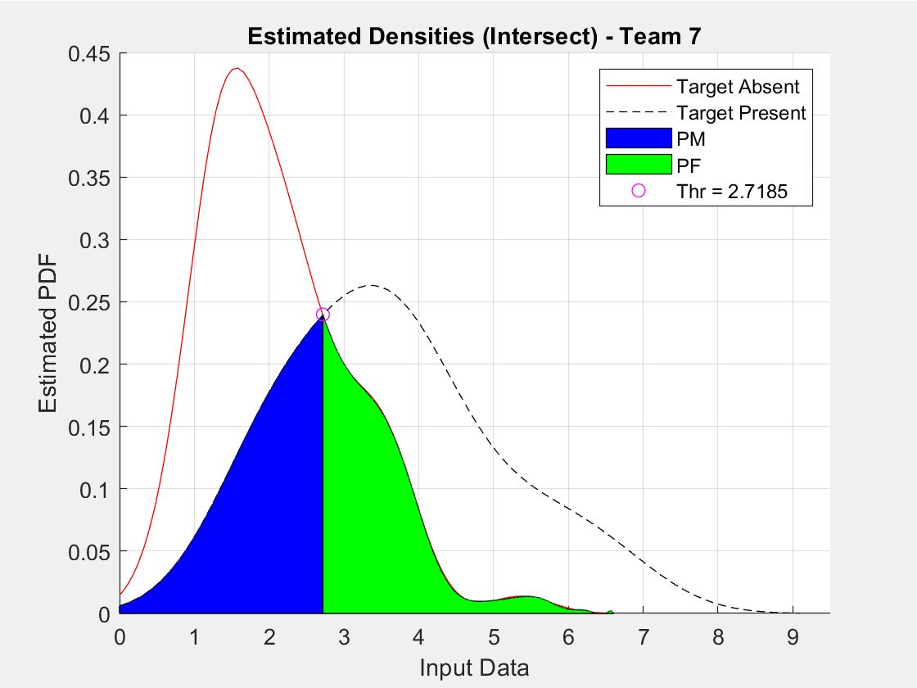

|  |  |  |  |
| --- | --- | --- | --- |
| **Confusion Matrix ROC Optimal Threshold = 2.5368** | | | |
| **Data Collected** | **Target Detected** | **Target Not Detected** | **Total Samples** |
| **Target Absent** | 19 | 51 | 70 |
| **Target Present** | 24 | 6 | 30 |
| **Total Samples** | 43 | 57 | 100 |

|  |  |  |  |
| --- | --- | --- | --- |
| **Confusion Matrix ksdensity Intersection Threshold = 2.7185** | | | |
| **Data Collected** | **Target Detected** | **Target Not Detected** | **Total Samples** |
| **Target Absent** | 16 | 54 | 70 |
| **Target Present** | 21 | 9 | 30 |
| **Total Samples** | 37 | 63 | 100 |